Student Wellness Check-In Tool
Supporting Student Well-Being & Engagement
This check-in helps us better support you. Your responses are confidential.
Date: ____________
Grade/Class: ____________
MOOD CHECK-IN
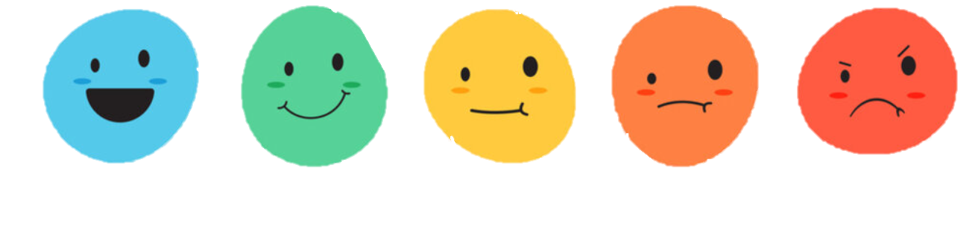
How are you feeling today? Let us know (circle one)
Bad
Poor
Medium
Good
Excellent

Energy level

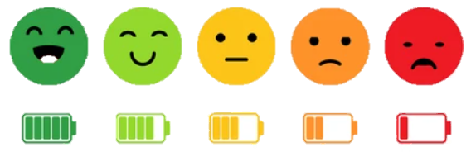
How’s your energy level today? Do you feel well-rested? (circle one)

Stress level
How’s your stress level today? Do you feel relaxed? (circle one)

Everything is ok   | I am a little  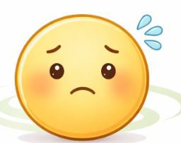  worried | I am feeling    stressed | I am upset   | 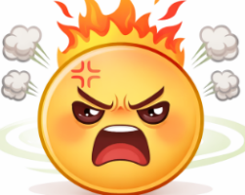  I’m going to explode!

