📚 Community Health Education
E2 Health Institute is committed to expanding access to clear, reliable health information. Through education and community engagement, we help individuals and families build the knowledge and confidence needed to navigate health topics that affect their everyday lives.
Our long-term goal is to provide educational resources that support communities in making informed decisions about health and wellness.
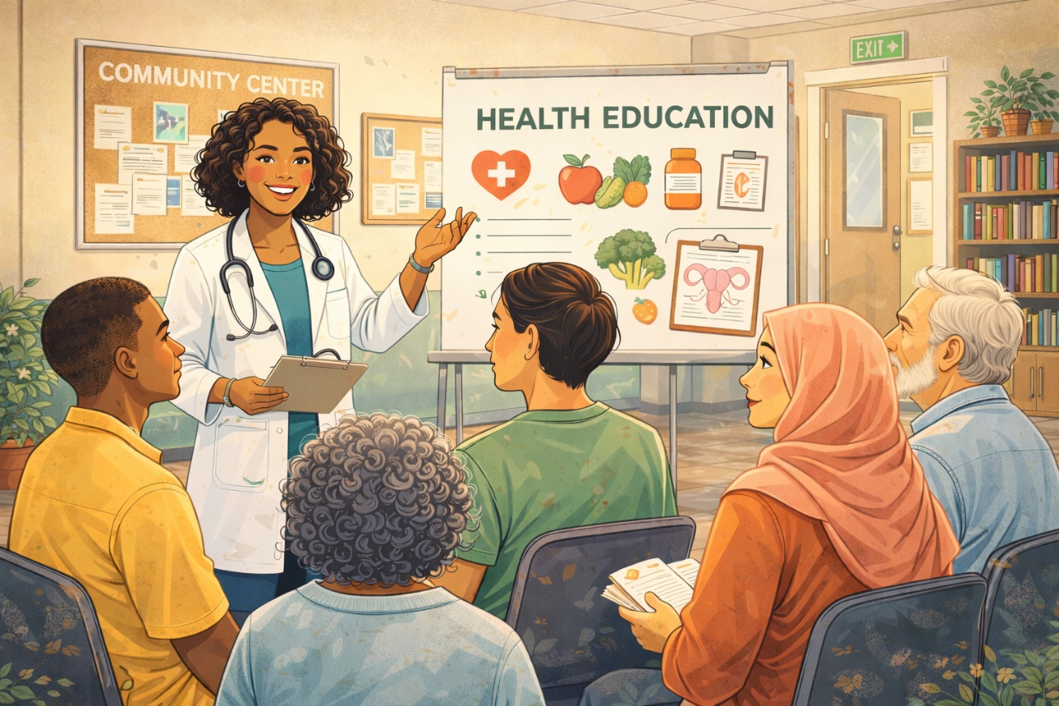
Education

